***Keyword - Driven Testing***

*REGISTRATION FUNCTIONALITY Automation Project*

Name: Niraimadai iyyanar m. (batch code: 2023 - 11123)

2024

## Introduction

Keyword-Driven Testing (KDT) is a powerful framework for automated testing that allows testers to abstract the complexity of test scripts into manageable keywords. When combined with Selenium, a popular tool for automating web browsers, it provides a robust solution for testing web applications.

**What is Keyword-Driven Testing?**

Keyword-Driven Testing is an approach where test cases are built using a set of keywords that represent actions or operations. These keywords are typically mapped to functions or methods in the testing framework, making tests highly modular and reusable.

## Objectives

The objective of implementing Keyword-Driven Testing with Selenium and Java is to enhance the efficiency, maintainability, and scalability of automated test suites for web applications. By abstracting test logic into reusable keywords, this approach aims to:

1. **Maximize Reusability:** Develop a modular testing framework where individual actions and validations are encapsulated as keywords, promoting code reuse across multiple test cases.
2. **Facilitate Maintenance:** Simplify test case maintenance by decoupling test scripts from implementation details. Updates and modifications can be easily managed through changes in the keyword repository without altering test logic
3. **Ensure Consistency:** Achieve consistent test execution by standardizing actions and validations through predefined keywords, reducing the risk of errors and discrepancies in testing.
4. **Support Scalability:** Enable the framework to grow alongside application development, accommodating new features and functionalities without extensive script rewriting.

## Existing System

In the existing system, the Registration functionality of the web application is tested manually. This process involves testers manually entering various sets of user credentials into the Registration form to verify if the Registration process works correctly. Manual testing can be time-consuming, prone to errors, and is not efficient for validating multiple test scenarios. Automating this process can significantly improve testing efficiency and accuracy.

**1.4 Tools and Technologies**

* Selenium WebDriver
* Java
* Maven
* IDE (Ex-Eclipse)

## Screenshots

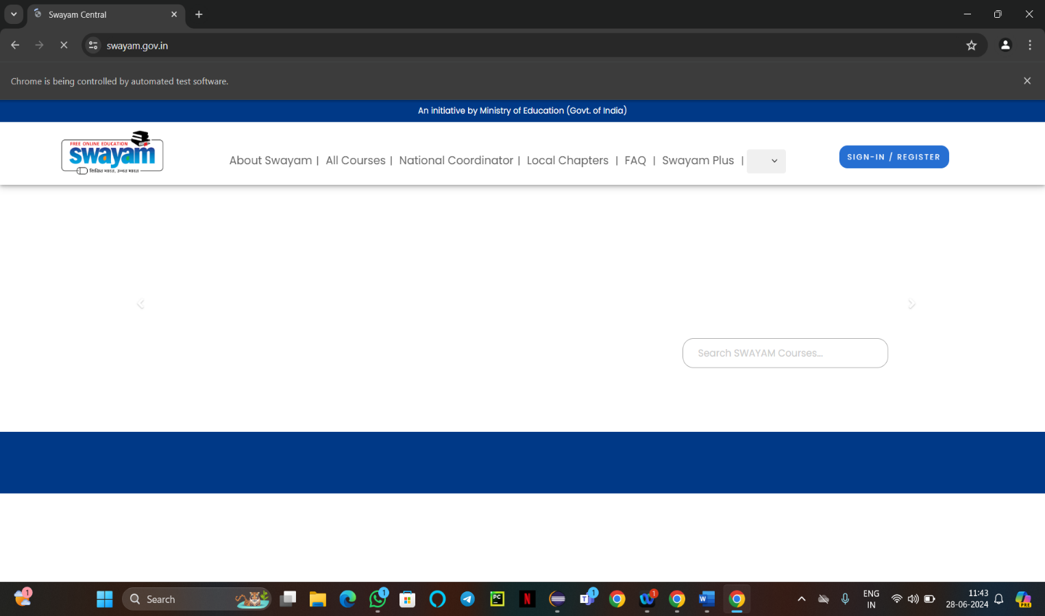

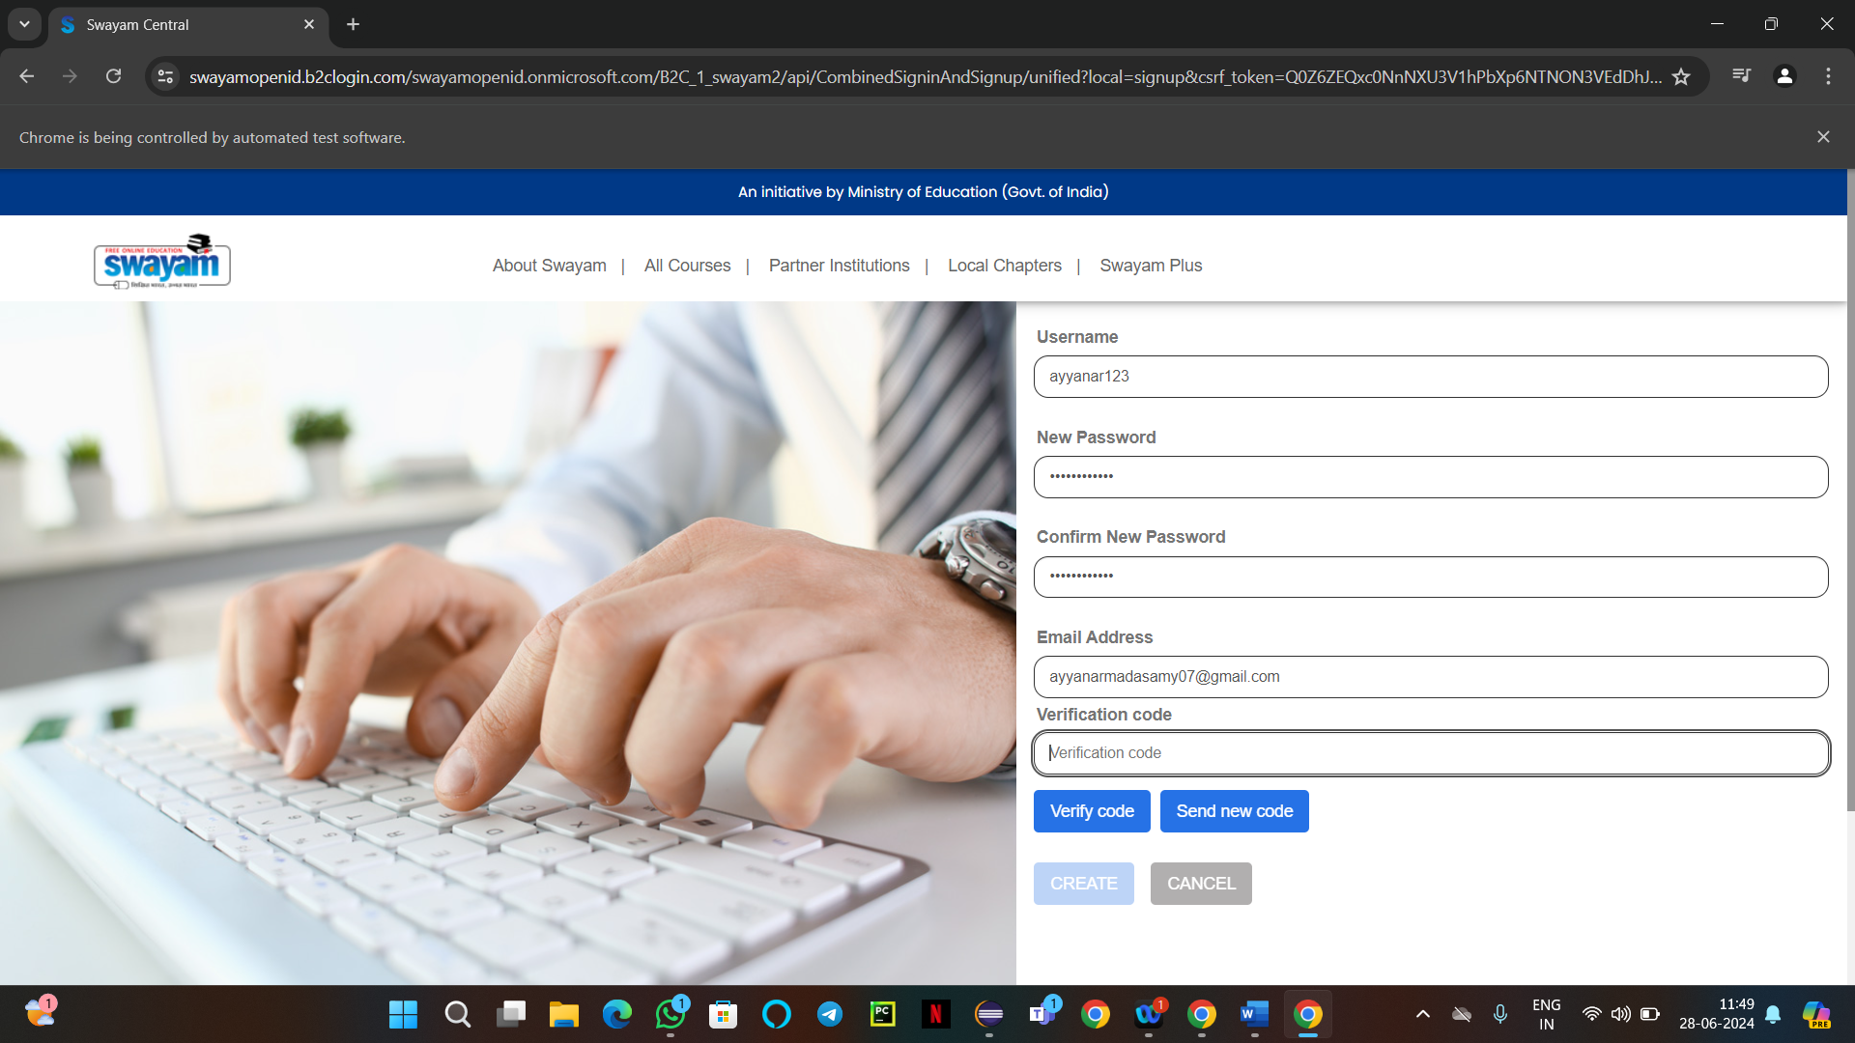

## 

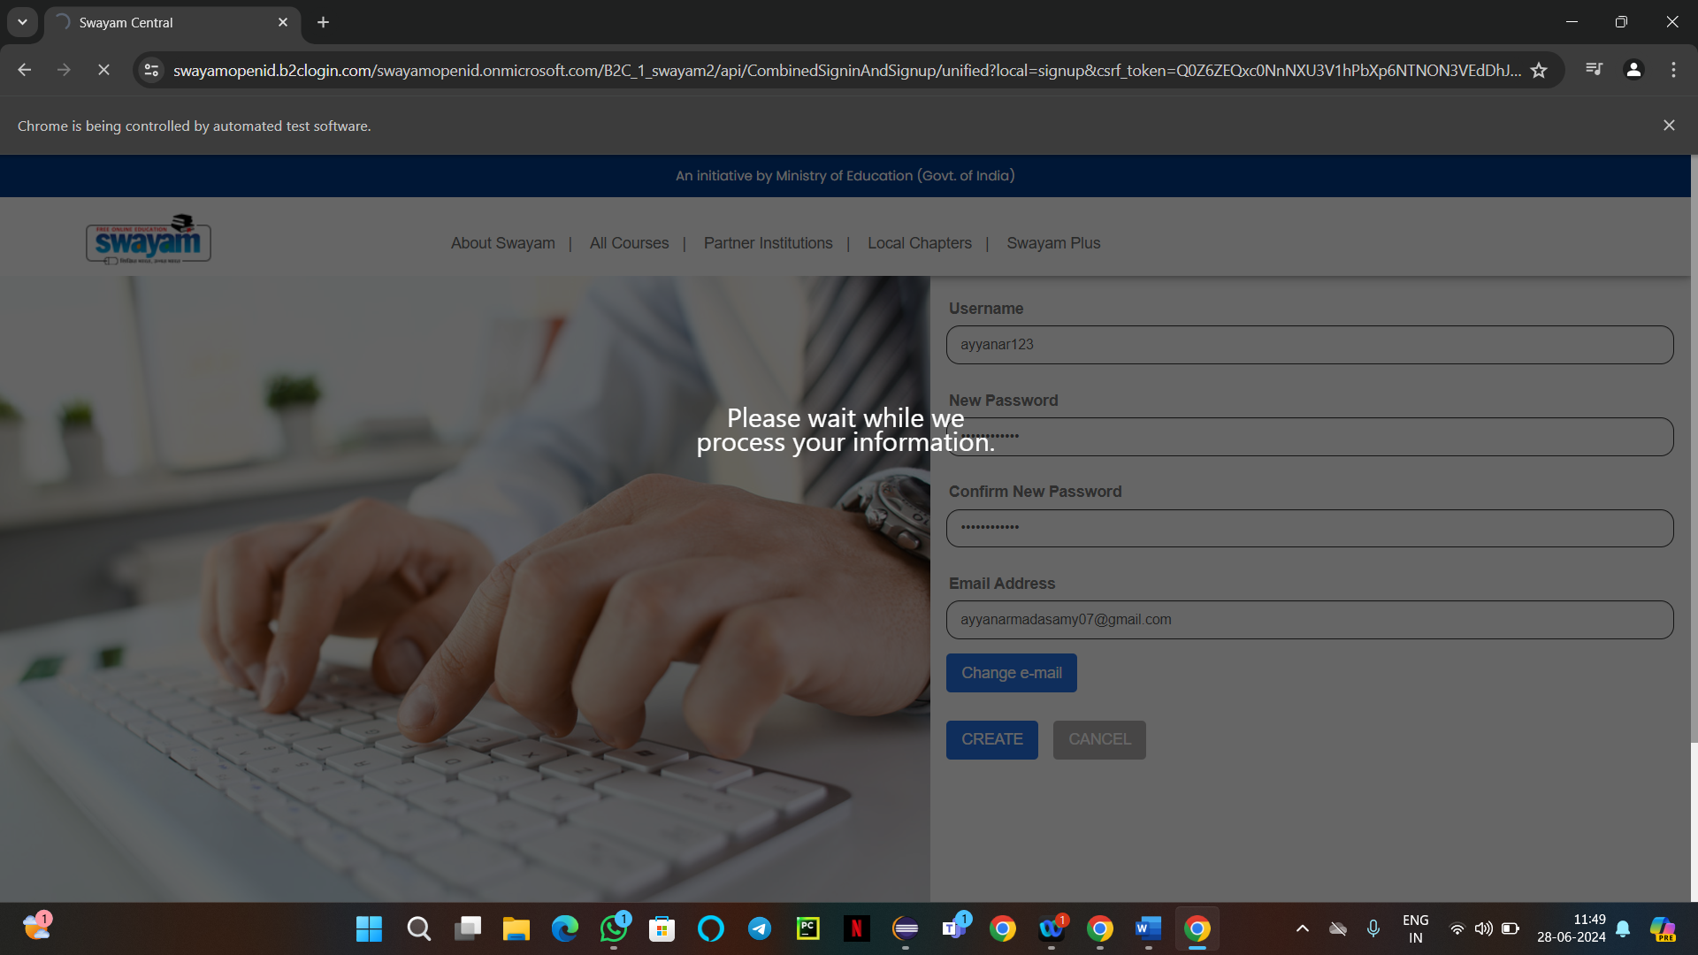



## Conclusion

Keyword-Driven Testing with Selenium and Java offers a structured approach to automated testing, enhancing maintainability, reusability, and scalability of test suites. By abstracting test logic into keywords, teams can achieve comprehensive test coverage efficiently, ensuring the quality and reliability of web applications.

____________________________________________________________________________________________